**Assignment JAVA Programs**

1. to print "Hello World"

**Code:**

public class Main1 {

    public static void main(String[] args) {

        System.out.println("Hello World");

    }

}

**Output Screenshot:**

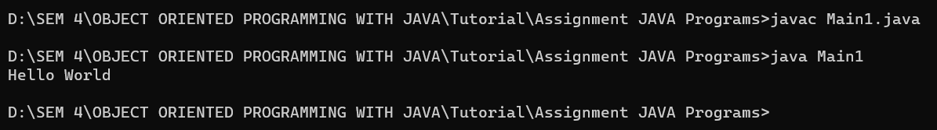

2. to find highest from two numbers using command line arguments.

**Code:**

public class Main2 {

    public static void main(String[] args) {

        if (args.length < 2) {

            System.out.println("Please provide two numbers as command line arguments.");

            return;

        }

        int num1 = Integer.parseInt(args[0]);

        int num2 = Integer.parseInt(args[1]);

        int highest = (num1 > num2) ? num1 : num2;

        System.out.println("The highest number is: " + highest);

    }

}

**Output Screenshot:**

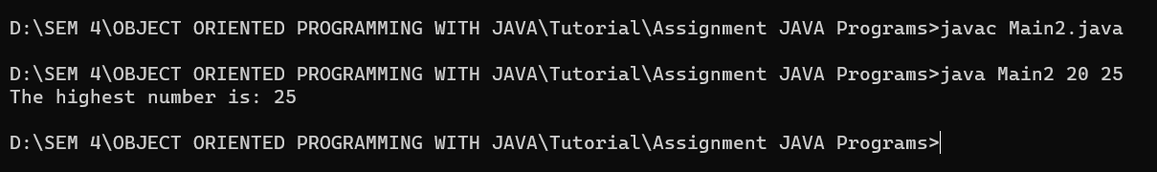

3. to find highest from two numbers entered by the users through the keyboard.

**Code:**

import java.util.Scanner;

public class Main3 {

    public static void main(String[] args) {

        Scanner scanner = new Scanner(System.in);

        System.out.print("Enter first number: ");

        int num1 = scanner.nextInt();

        System.out.print("Enter second number: ");

        int num2 = scanner.nextInt();

        int highest = (num1 > num2) ? num1 : num2;

        System.out.println("The highest number is: " + highest);

        scanner.close();

    }

}

**Output Screenshot:**

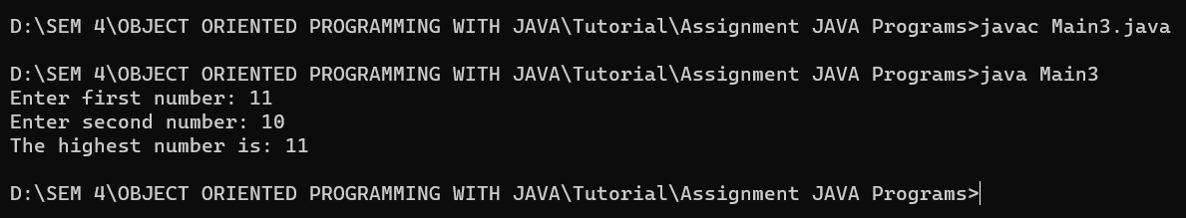

4. to check whether a given number is prime or not.

**Code:**

import java.util.Scanner;

public class Main4 {

    public static void main(String[] args) {

        Scanner scanner = new Scanner(System.in);

        System.out.print("Enter a number: ");

        int num = scanner.nextInt();

        boolean isPrime = true;

        if (num <= 1) {

            isPrime = false;

        } else {

            for (int i = 2; i <= Math.sqrt(num); i++) {

                if (num % i == 0) {

                    isPrime = false;

                    break;

                }

            }

        }

        if (isPrime) {

            System.out.println(num + " is a prime number.");

        } else {

            System.out.println(num + " is not a prime number.");

        }

        scanner.close();

    }

}

**Output Screenshot:**

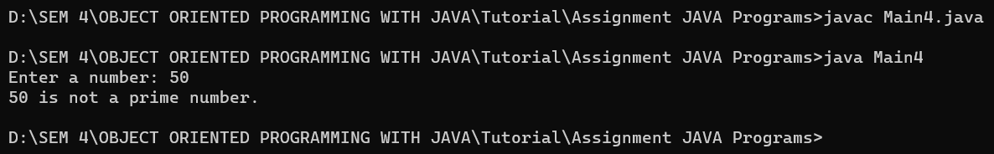

5. to find all pallindrome numbers in a specific range entered by the user.

**Code:**

import java.util.Scanner;

public class Main5 {

    public static void main(String[] args) {

        Scanner scanner = new Scanner(System.in);

        System.out.print("Enter the lower limit of the range: ");

        int lowerLimit = scanner.nextInt();

        System.out.print("Enter the upper limit of the range: ");

        int upperLimit = scanner.nextInt();

        System.out.println("Palindrome numbers in the range " + lowerLimit + " to " + upperLimit + " are:");

        for (int i = lowerLimit; i <= upperLimit; i++) {

            if (isPalindrome(i)) {

                System.out.print(i + " ");

            }

        }

        scanner.close();

    }

    public static boolean isPalindrome(int num) {

        int reversedNum = 0;

        int originalNum = num;

        while (num != 0) {

            int digit = num % 10;

            reversedNum = reversedNum * 10 + digit;

            num /= 10;

        }

        return originalNum == reversedNum;

    }

}

**Output Screenshot:**

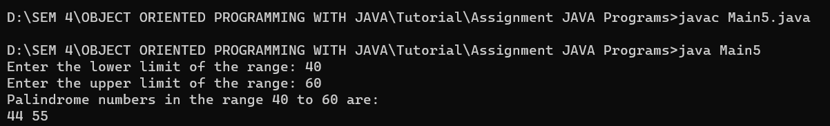

6. to find highest from an array of size N.

**Code:**

class Main6 {

    static int arr[] = { 10, 324, 45, 90, 9808 };

    static int largest() {

        int i;

        int max = arr[0];

        for (i = 1; i < arr.length; i++)

            if (arr[i] > max)

                max = arr[i];

        return max;

    }

    public static void main(String[] args) {

        System.out.println("Largest in given array is " + largest());

    }

}

**Output Screenshot:**

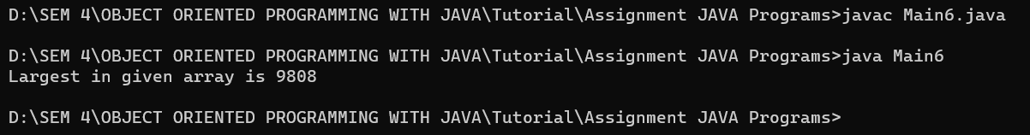

7. Store 5 elements in an array and print it.

**Code:**

import java.util.Scanner;

public class Main7 {

    public static void main(String[] args) {

        Scanner scanner = new Scanner(System.in);

        System.out.print("Enter the height of the triangle: ");

        int height = scanner.nextInt();

        for (int i = 1; i <= height; i++) {

            for (int j = 1; j <= i; j++) {

                System.out.print("* ");

            }

            System.out.println();

        }

        scanner.close();

    }

}

**Output Screenshot:**

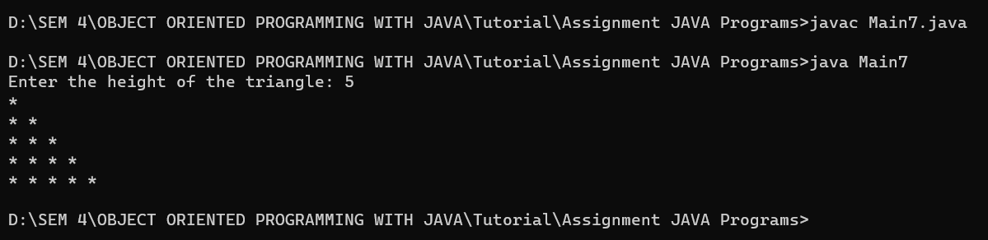

8. to perform addition of two matrices of size M x N.

**Code:**

import java.util.Scanner;

public class Main8 {

    public static void main(String[] args) {

        Scanner scanner = new Scanner(System.in);

        System.out.print("Enter the number of rows of the matrix: ");

        int rows = scanner.nextInt();

        System.out.print("Enter the number of columns of the matrix: ");

        int cols = scanner.nextInt();

        int[][] matrix1 = new int[rows][cols];

        int[][] matrix2 = new int[rows][cols];

        int[][] sumMatrix = new int[rows][cols];

        System.out.println("Enter the elements of matrix 1:");

        for (int i = 0; i < rows; i++) {

            for (int j = 0; j < cols; j++) {

                matrix1[i][j] = scanner.nextInt();

            }

        }

        System.out.println("Enter the elements of matrix 2:");

        for (int i = 0; i < rows; i++) {

            for (int j = 0; j < cols; j++) {

                matrix2[i][j] = scanner.nextInt();

            }

        }

        for (int i = 0; i < rows; i++) {

            for (int j = 0; j < cols; j++) {

                sumMatrix[i][j] = matrix1[i][j] + matrix2[i][j];

            }

        }

        System.out.println("The sum of the two matrices is:");

        for (int i = 0; i < rows; i++) {

            for (int j = 0; j < cols; j++) {

                System.out.print(sumMatrix[i][j] + " ");

            }

            System.out.println();

        }

        scanner.close();

    }

}

**Output Screenshot:**

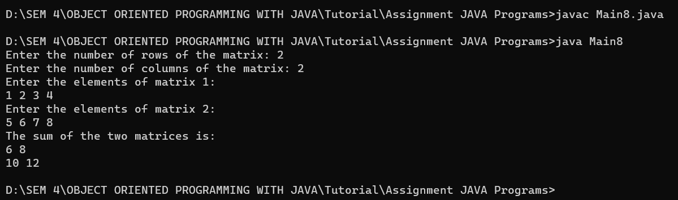

9. to compare whether two strings are same or not

**Code:**

public class Main9 {

    public static void main(String[] args) {

        String str1 = "hello";

        String str2 = "world";

        if (str1.equals(str2)) {

            System.out.println("The strings are the same.");

        } else {

            System.out.println("The strings are different.");

        }

    }

}

**Output Screenshot:**

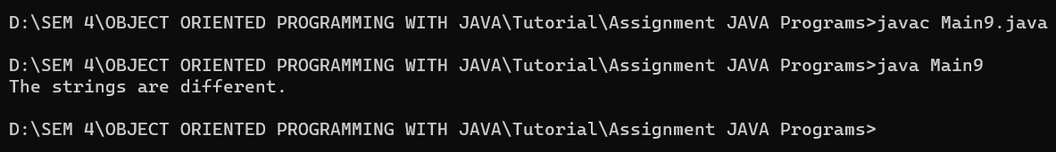

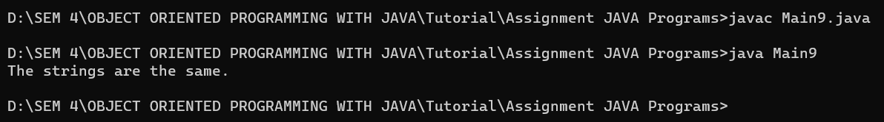

10. to check wether a word occurs in a string or not.

**Code:**

public class Main10 {

    public static void main(String[] args) {

        String str = "The quick brown fox jumps over the lazy dog";

        String word = "fox";

        if (str.contains(word)) {

            System.out.println("The word '" + word + "' occurs in the string.");

        } else {

            System.out.println("The word '" + word + "' does not occur in the string.");

        }

    }

}

**Output Screenshot:**

